- GPUs AND COOLING SYSTEM

Q1. Open your own laptop or desktop (or use an online PC hardware simulator if you don't have access to a real system) and identify the GPU model installed. Write down the GPU's brand, model number, and whether it is integrated or dedicated.
Ans. I have the Asus TUF A15 Series Laptop and it’s Specification is as follows
- GPU BRAND – NVIDIA
- GPU MODEL – NVIDIA GeForce RTX 4060 Laptop GPU
- TYPE – It is a dedicated Graphics Card
- My GPU has 8GB of VRAM and it is a dedicated GPU designed for gaming, video editing, 3D Rendering, AI, and other graphics-intensive task.
- Here’s The Difference Between Dedicated GPU and Integrated GPU
Integrated GPU | Dedicated GPU
Built into the CPU. | Separate graphics card or chip.
Uses the computer's RAM. | Has its own VRAM (Video RAM).
Lower graphics performance. | Higher graphics performance.
Uses less power. | Uses more power.
Best for everyday tasks and light gaming. | Best for gaming, video editing, and 3D work.

Q2. Take a clear photo or screenshot of the cooling system (fan, heatsink, or liquid cooling setup) inside your PC or from a PC hardware simulator. Label the main cooling components and briefly describe their function.
Ans.
Cooling Fan
Heat Pipes
Cooling Fan
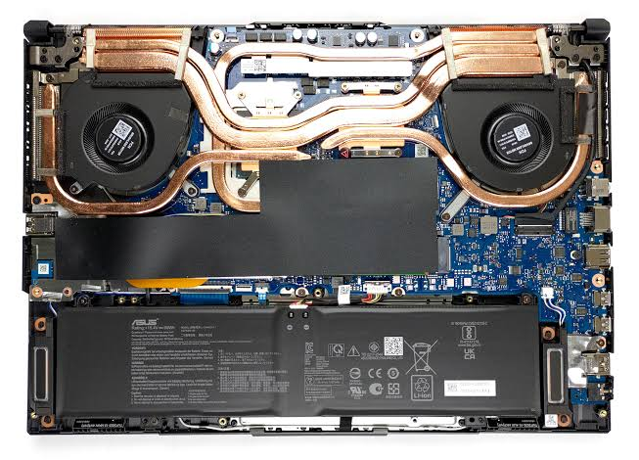
CPU and GPU
Heat Sink
Heat Sink
- Cooling System Components in Your Laptop
- Cooling Fans (2)
- Location: Top-left and Top-right of the image.
- Function: Draw cool air into the laptop and push hot air out through the vents, keeping the CPU and GPU cool.
- Heat Pipes
- Location: The curved Copper pipes connecting both fans.
- Function: Carry heat away from the CPU and GPU to the heatsinks near the fans.
- Heatsinks
- Location: Under the black finned sections next to each fan (where the heat pipes end).
- Function: Dissipate heat from the heat pipes so the fans can blow it out of the laptop.
- CPU and GPU
- Location: Under the copper heat transfer base cover in the centre, connected to the heat pipes.
- Function: These are the main processing chips that generate most of the heat during gaming and heavy workloads.

- Brief Description
- The cooling system in my laptop consists of two cooling fans, multiple heat pipes, and heatsinks. The heat pipes transfer heat from the CPU and GPU to the heatsinks, where the fans blow the hot air out of the laptop through the exhaust vents. This keeps the laptop at a safe operating temperature and helps maintain good performance during gaming and other demanding tasks.
Q3. Create a comparison table listing at least 3 differences between air cooling and liquid cooling systems for GPUs, including factors like cost, efficiency, and maintenance.
Ans.
Factor | Air Cooling (GPU) | Liquid Cooling (GPU)
Cost | Less expensive and more affordable. | More expensive due to the pump, radiator, and tubing.
Cooling Efficiency | Good for normal gaming and everyday use. | Better at handling high temperatures during heavy gaming and overclocking.
Maintenance | Requires only occasional dust cleaning. | Needs regular maintenance, such as checking coolant levels (for custom loops) and ensuring there are no leaks.
Noise Level | Can become louder when the fans spin at high speed. | Usually quieter because the radiator dissipates heat more efficiently.
Installation | Easy to install and replace. | More complex to install, especially custom liquid cooling systems.

Q4. Imagine you are building a gaming PC for streaming IPL matches and playing graphics-heavy games. Choose between air cooling and liquid cooling for your GPU, and justify your choice in 3-4 sentences based on your research.
Ans. I would choose air cooling for my GPU. It is cheaper, easy to install, and requires very little maintenance, making it a practical choice for a gaming PC. It provides enough cooling for streaming IPL matches and playing graphics-heavy games without overheating. Air cooling is also reliable and offers good performance for most gamers. It is the best option for users who want good cooling performance at a lower cost.

